Create a second iOS target in React Native project

(1) Add a new target

Open the project setting in Xcode and click “+” to add a new target

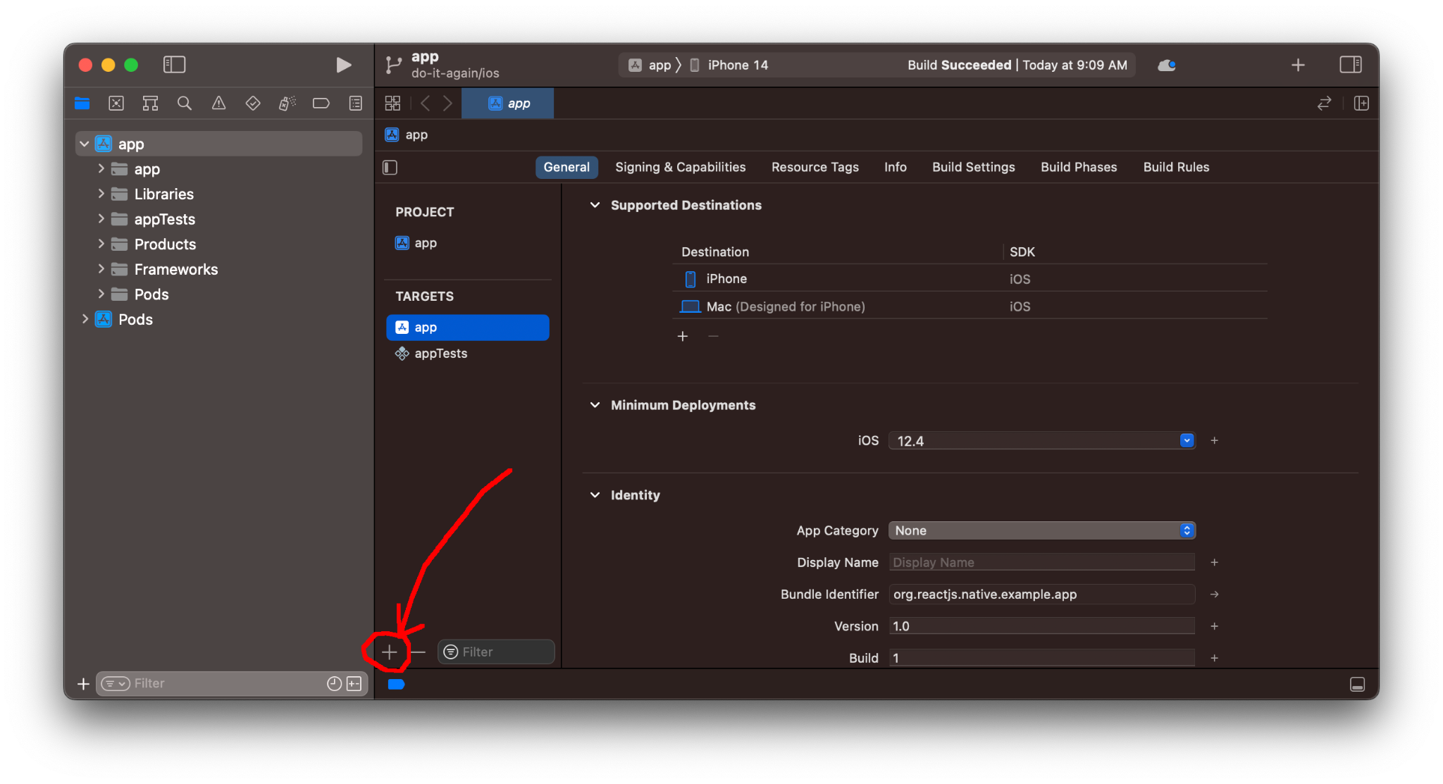

Choose Application/App

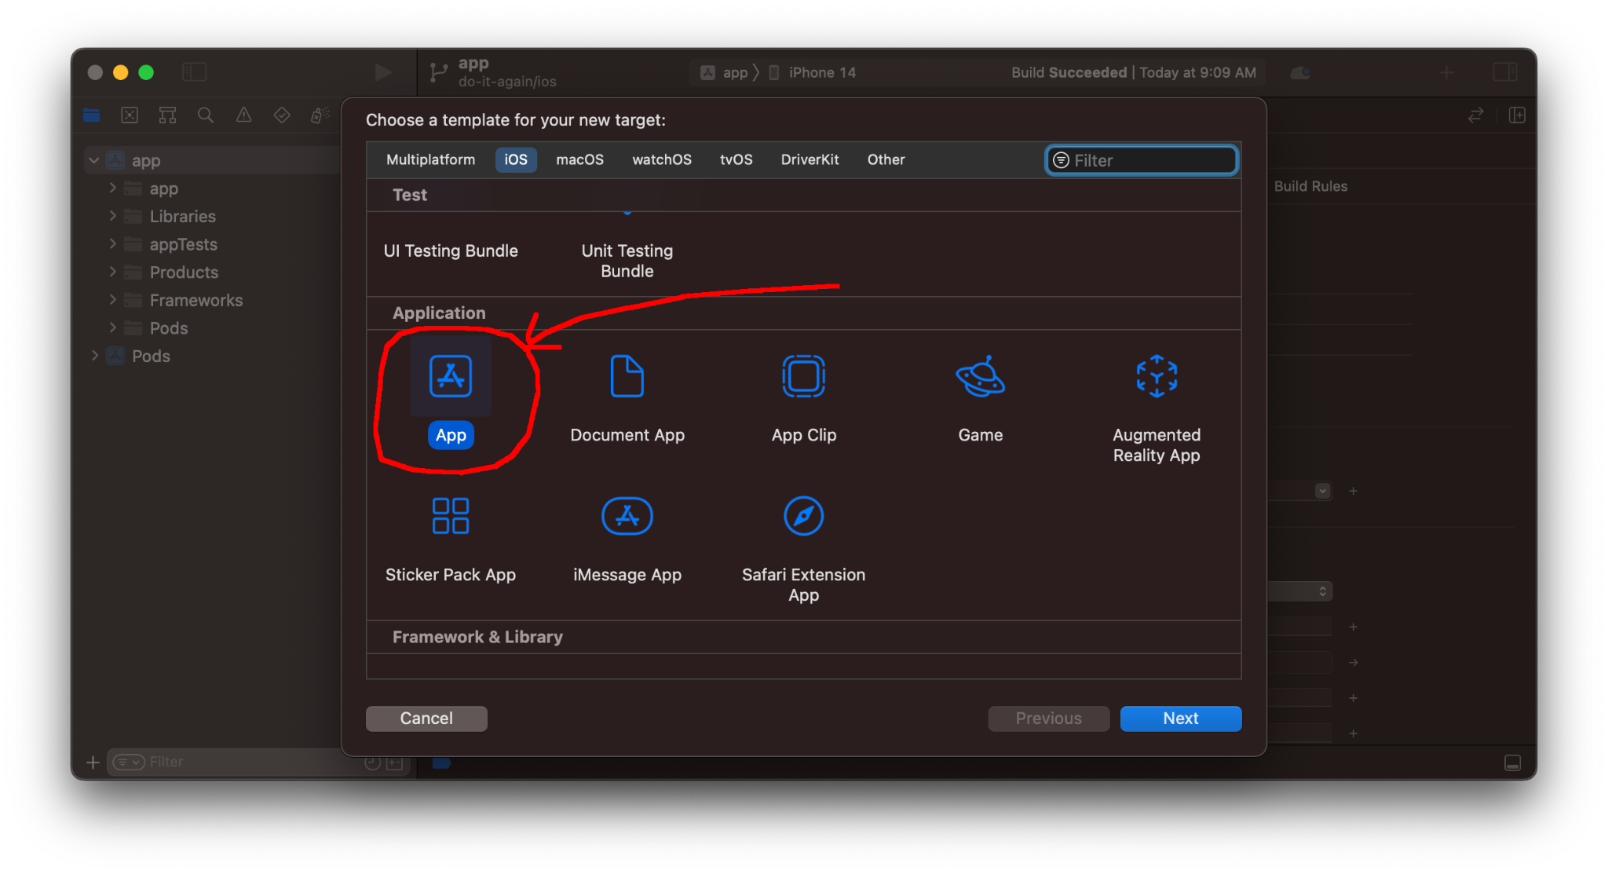

Choose a different “Project Name” for the new target, e.g. “app2”. Choose “Storyboard” for Interface and “Objective-C” for Language.

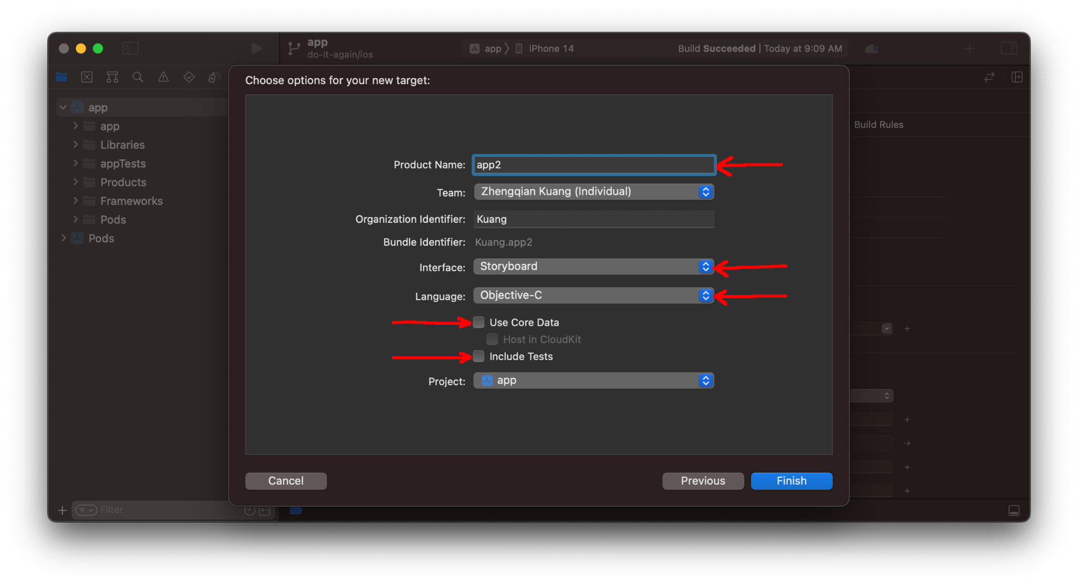

Remove the storyboard setting for app2:

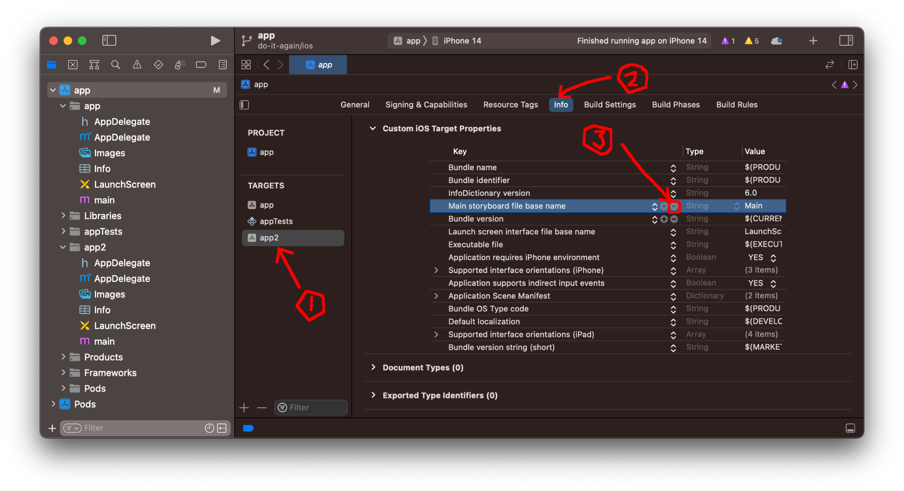

(2) Make an exact copy of app for app2

(2.1) Remove all the files and folders that are in app2

In Terminal,

`cd <RN_APP_ROOT>/ios/app2`

`rm -rf *`

In Xcode’s project tree panel, select all the files and folders that are under app2, right click on the selected items and delete them

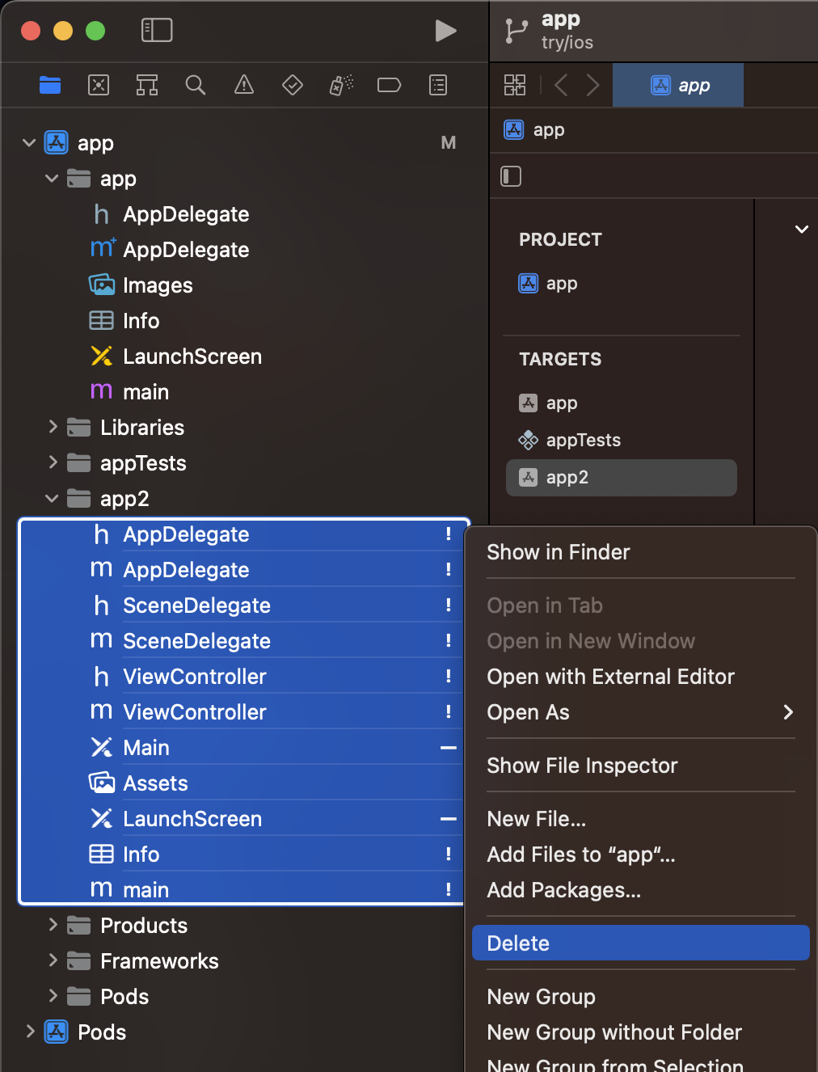

(2.2) Make an exact copy from app to app2

Go back to Terminal, copy all the files and folders in app to app2:

(at <RN_APP_ROOT>/ios/app2/)

`cp -R ../app/* .`

Go to Finder, select all the files and folders in <RN_APP_ROOT>/ios/app2/ and drag-and-drop them into Xcode under app2

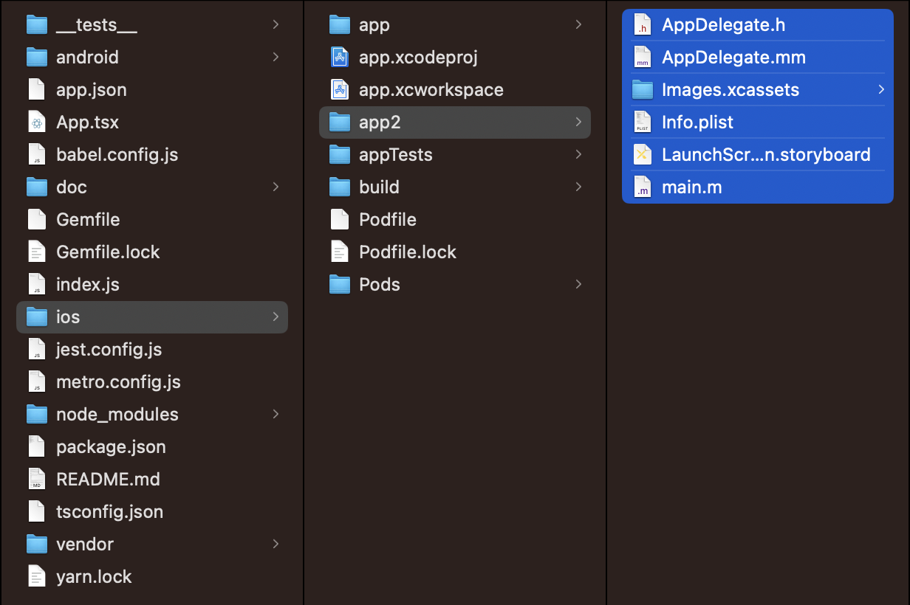

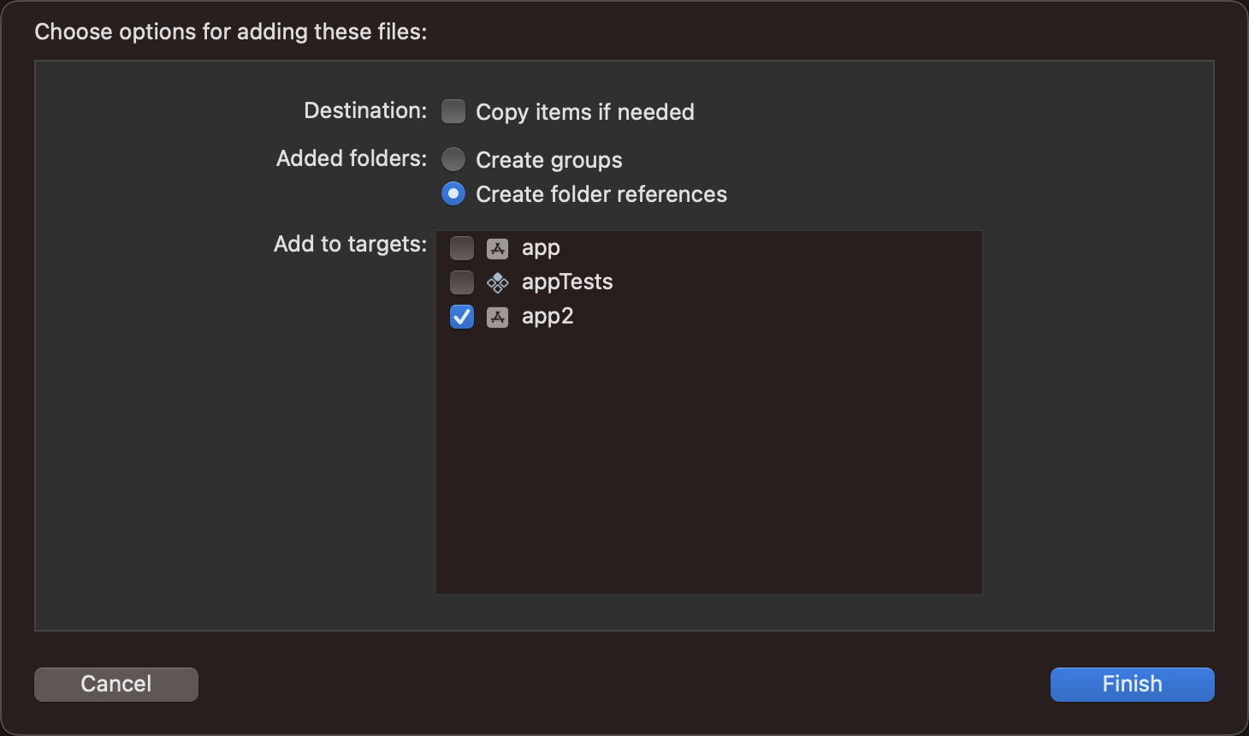

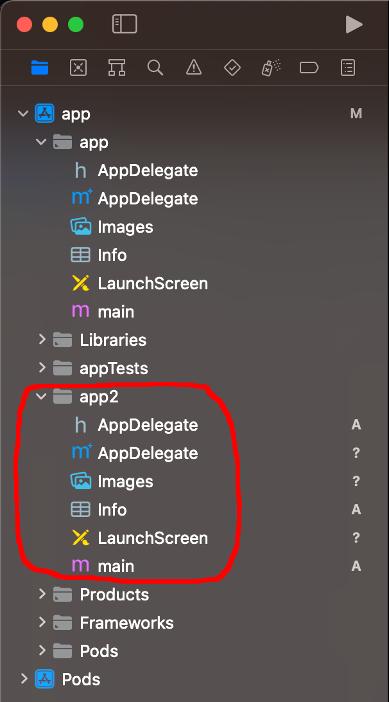

Click on the `Info` file under `app2`. In `Target Membership` section uncheck `app2` and in the edit area modify `Bundle display name` to `app2`:

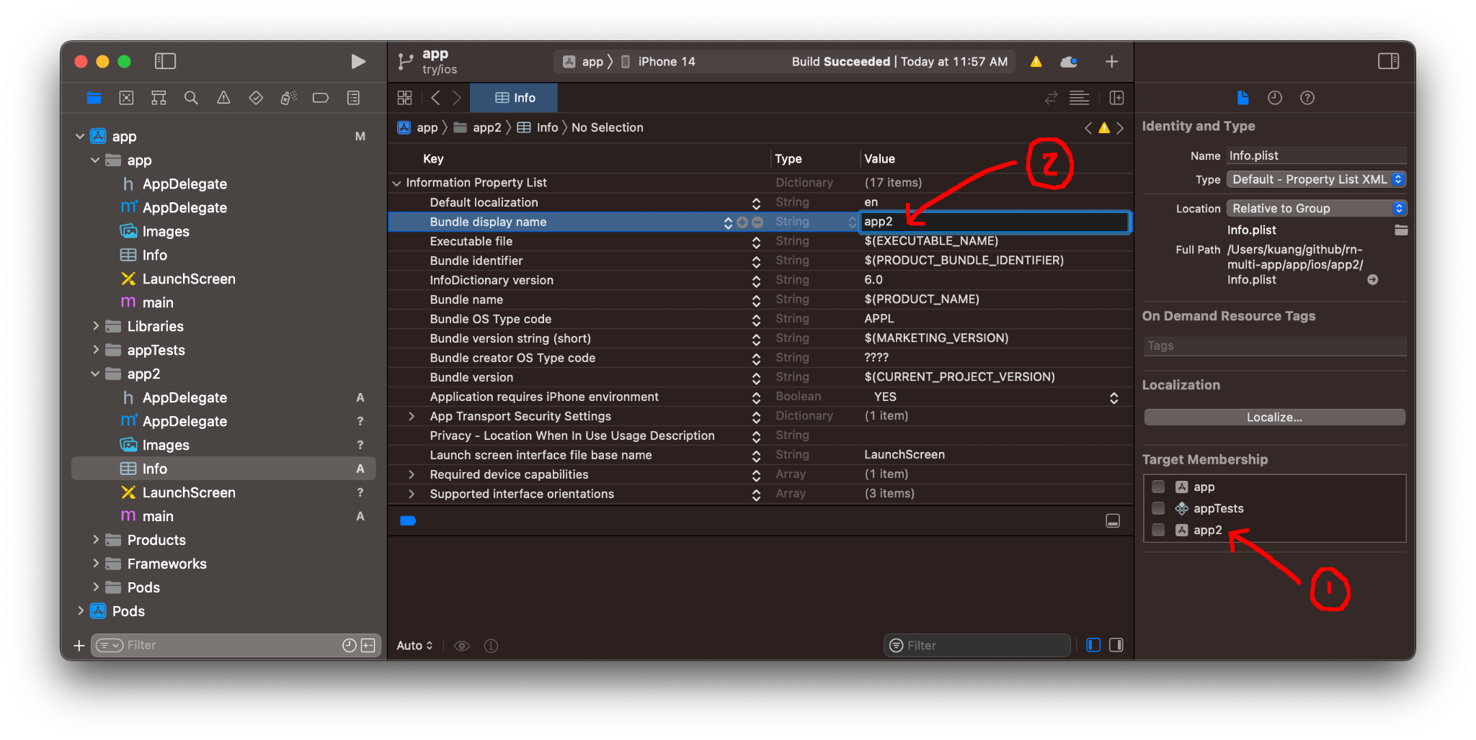

(3) Prepare Podfile for a multi-target project

(3.1) Create a SharedPodfile.rb

In Terminal,

`cd <RN_APP_ROOT>/ios`

`touch SharedPodfile.rb`

Open SharedPodfile.rb and add the following lines

```

def shared_postinstall

config = use_native_modules!

post_install do |installer|

# https://github.com/facebook/react-native/blob/main/packages/react-native/scripts/react_native_pods.rb#L197-L202

react_native_post_install(

installer,

config[:reactNativePath],

:mac_catalyst_enabled => false

)

__apply_Xcode_12_5_M1_post_install_workaround(installer)

end

end

```

(3.2) Open <RN_APP_ROOT>/ios/Podfile

Insert this line at the top of Podfile:

```

load './SharedPodfile.rb'

```

In `target 'app' do` section, Remove the two sections of

```

target 'appTests' do

…

end

```

and

```

post_install do |installer|

…

end

```

Copy and paste `target 'app' do` section and rename `target 'app'` to `target 'app2'`:

```

target 'app' do

config = use_native_modules!

# Flags change depending on the env values.

flags = get_default_flags()

use_react_native!(

:path => config[:reactNativePath],

# Hermes is now enabled by default. Disable by setting this flag to false.

:hermes_enabled => flags[:hermes_enabled],

:fabric_enabled => flags[:fabric_enabled],

# Enables Flipper.

#

# Note that if you have use_frameworks! enabled, Flipper will not work and

# you should disable the next line.

:flipper_configuration => flipper_config,

# An absolute path to your application root.

:app_path => "#{Pod::Config.instance.installation_root}/.."

)

end

target 'app2' do

config = use_native_modules!

# Flags change depending on the env values.

flags = get_default_flags()

use_react_native!(

:path => config[:reactNativePath],

# Hermes is now enabled by default. Disable by setting this flag to false.

:hermes_enabled => flags[:hermes_enabled],

:fabric_enabled => flags[:fabric_enabled],

# Enables Flipper.

#

# Note that if you have use_frameworks! enabled, Flipper will not work and

# you should disable the next line.

:flipper_configuration => flipper_config,

# An absolute path to your application root.

:app_path => "#{Pod::Config.instance.installation_root}/.."

)

end

```

At the very end of Podfile, add

```

shared_postinstall

```

And the final Podfile should look like this

```

load './SharedPodfile.rb'

# Resolve react_native_pods.rb with node to allow for hoisting

require Pod::Executable.execute_command('node', ['-p',

'require.resolve(

"react-native/scripts/react_native_pods.rb",

{paths: [process.argv[1]]},

)', __dir__]).strip

platform :ios, min_ios_version_supported

prepare_react_native_project!

# If you are using a `react-native-flipper` your iOS build will fail when `NO_FLIPPER=1` is set.

# because `react-native-flipper` depends on (FlipperKit,...) that will be excluded

#

# To fix this you can also exclude `react-native-flipper` using a `react-native.config.js`

# ```js

# module.exports = {

# dependencies: {

# ...(process.env.NO_FLIPPER ? { 'react-native-flipper': { platforms: { ios: null } } } : {}),

# ```

flipper_config = ENV['NO_FLIPPER'] == "1" ? FlipperConfiguration.disabled : FlipperConfiguration.enabled

linkage = ENV['USE_FRAMEWORKS']

if linkage != nil

Pod::UI.puts "Configuring Pod with #{linkage}ally linked Frameworks".green

use_frameworks! :linkage => linkage.to_sym

end

target 'app' do

config = use_native_modules!

# Flags change depending on the env values.

flags = get_default_flags()

use_react_native!(

:path => config[:reactNativePath],

# Hermes is now enabled by default. Disable by setting this flag to false.

:hermes_enabled => flags[:hermes_enabled],

:fabric_enabled => flags[:fabric_enabled],

# Enables Flipper.

#

# Note that if you have use_frameworks! enabled, Flipper will not work and

# you should disable the next line.

:flipper_configuration => flipper_config,

# An absolute path to your application root.

:app_path => "#{Pod::Config.instance.installation_root}/.."

)

end

target 'app2' do

config = use_native_modules!

# Flags change depending on the env values.

flags = get_default_flags()

use_react_native!(

:path => config[:reactNativePath],

# Hermes is now enabled by default. Disable by setting this flag to false.

:hermes_enabled => flags[:hermes_enabled],

:fabric_enabled => flags[:fabric_enabled],

# Enables Flipper.

#

# Note that if you have use_frameworks! enabled, Flipper will not work and

# you should disable the next line.

:flipper_configuration => flipper_config,

# An absolute path to your application root.

:app_path => "#{Pod::Config.instance.installation_root}/.."

)

end

shared_postinstall

```

(3.3) Verify the Podfile

In Terminal,

`cd <RN_APP_ROOT>/ios`

`pod install`

(4) Build and run the two targets app and app2